Specification
1. Full duplex 64-bit PCI bus master
2. Integrated SRS 3D sound technology
3. Compatible with Sound Blaster, Sound Blaster Pro and Windows sound system
4. Advanced MPC-3 compliant input and output mixer
5. Enhanced stereo full duplex operation
6. Dual Type-F DMA support
7. Delta-Sigima data converters
8. Programmable power management
9. Hardware master volume control
10. Line-in, microphone and line-out jacks
11. PCI Interface
Requirements
1. Available PCI slot
2. CD-ROM for driver installation
3. Speakers
4. Windows95/98/2000/ME/XP.
Hardware installation
It is recommended that you remove any previously installed sound card and drivers prior to installing this 4 Channel PCI Sound Card to avoid any conflicts. If previously installed drivers are not removed, this 4 Channel PCI Sound Card perhaps not function properly. (Note: If your computer has on-board sound you will need to disable it on the motherboard. For more information please see your computer’s documentation or contact your computer’s manufacturer.)
Otherwise, before installing the device, please ensure turning off your computer and unplug the power cord to prevent damage to the devices and the system components.

To install the sound card . please follow the steps below:
1、Disconnect your computer from the power source
2、Open the computer case
3、Locate an available PCI slot on your computer, and insert this 4 Channel PCI Sound Card into the slot.
4、Fasten the card to the case using a screw
5、Close the computer case, plug the peripherals into the corresponding jack of the sound card.

Software Installation
1、Start your PC, place the Driver CD into the CD-ROM drive and then you will find drivers for XP,7.0and Vista and the setup file for each .
2、Follow any on-screen instructions to complete the software installation.
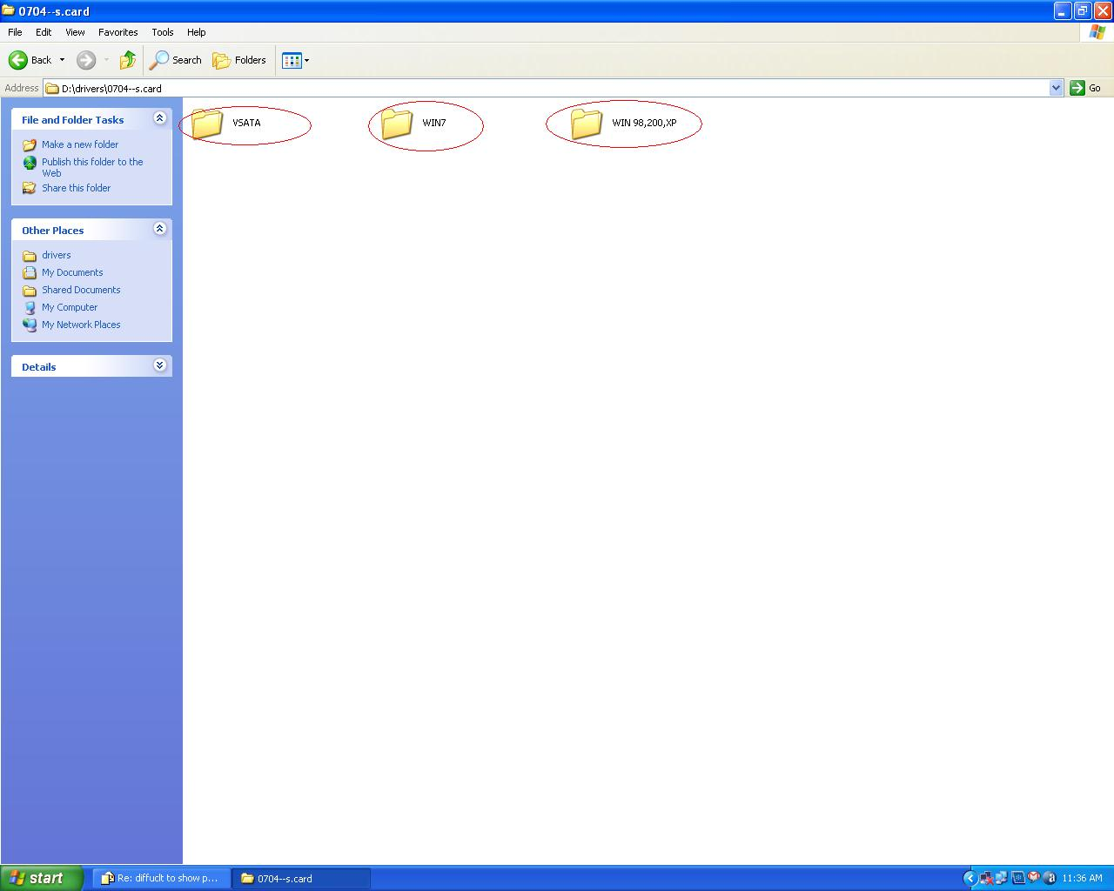
3、Restart your system
4、Once you have rebooted the computer, this 4 Channel PCI Sound card is ready to be used.

7.0 Safety Guide
1、This sound Card has many precision electronic components which can be damaged by unwanted electrical energy from many different source. So, except you want to start the installation, don’t take it out from the Static Shielding bag
2、when use the sound card from shielding bag, it had better taking antistatic gloves that minimize the handling of electronic assemblies and components to prevent damage
3、Place the computer system on a stable surface to prevent improper installation from the shaking and please make sure all the screws or other metal parts get it well to avoid the short occurred.

There you can also fill out our technical support form if you have any questions.

